My pursuit annotating images in COCO format
First a video needs to be shot from which images can be distracted. This video can be converted (if necessary) using VLC Media Player. After converting the video one should split the video up in frames in order to annotate them. A tool to do this is FFMPEG, but this can also be done by VLC.

1. Approach 1
Now that we have to images that need to be labelled, we can start labelling them in the LabelMe web annotation tool. This annotation tool generates .xml format files, this is the same format as is used for the Pascal VOC data set and looks like this:
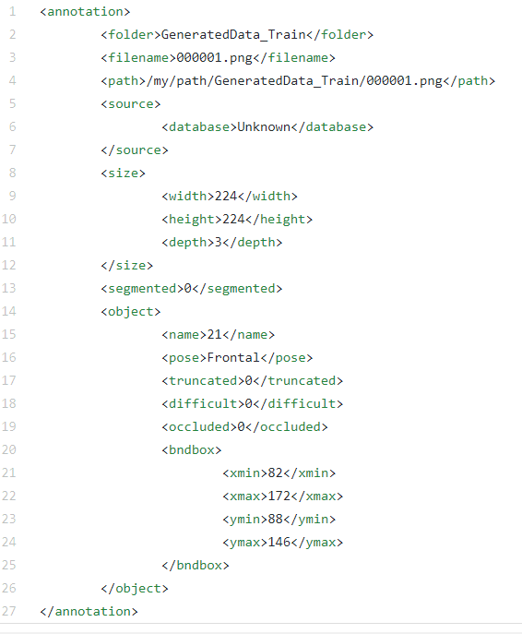
After this we have a lot of.xml files which we need to convert to the JSON format of the COCO dataset. First, we need to take a look at how keypoints are annotated in the COCO dataset.

1.1. Results of LabelMe Web Annotation Tool
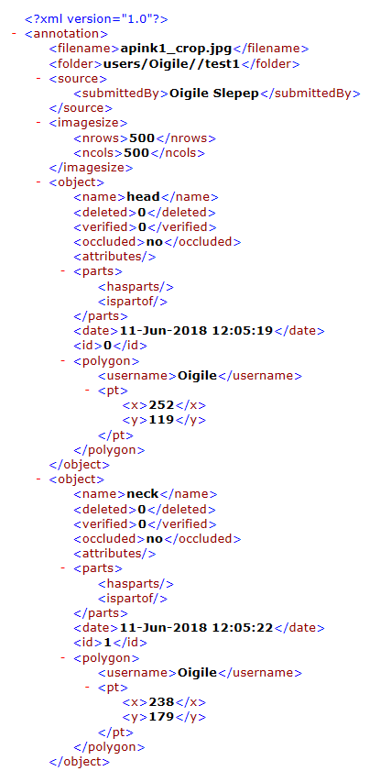
Etc.

1.2. COCO Keypoint format
All COCO annotation files start as:
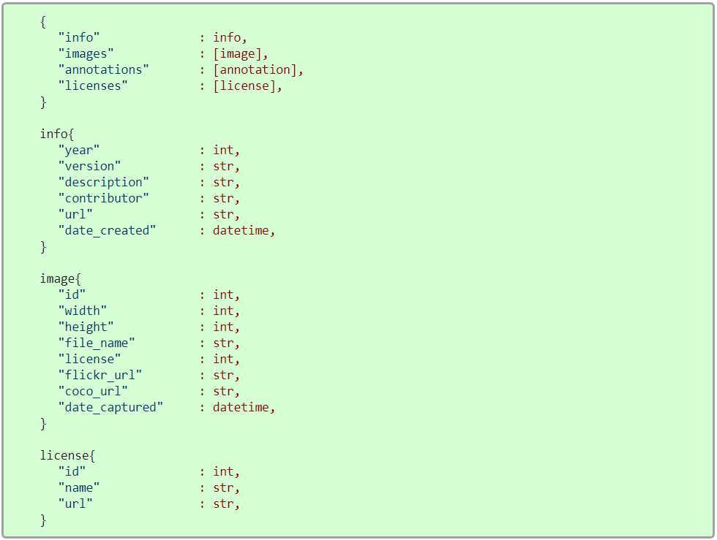
For the keypoint annotations the following fields are necessary:
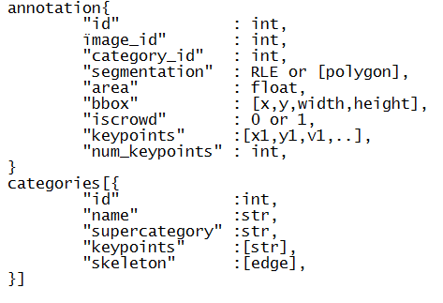
X and y stand for the location of the keypoint, whereas v stands for the visibility. If v=0: not labeled, v=1: labeled but not visible and v=2: labeled and visibile.

1.3. Convert from the .xml format to COCO key point format.
See the scripts uploaded in this Gitub repository. The following has been done.

1.3.1. Single image conversion – single person
For the single image conversion one needs to distract the information needed for the COCO format from the .xml file. This is done by the functions etc. in the DOMParser.java file. The information distracted from the .xml file is the following:
- File name
- The size of the image
- Keypoint names, whether they are occluded or not, x and y coordinates.
- The bounding box of the person depicted.
- One should annotate the bbox as a polygon (as is the default in the LabelMe tool) and label the bounding box as last!
In the SingleFileConversion.java file the COCOFormat template created based on the COCO format is used to store the information distracted from the xml file. Major functions in this file are the keypoints (x,y,v,…) array construction function, the number of keypoints function and the random number generators. For the image id the random number should have 7 digits and for the annotation id 6 digits are used.

